DreamStream™ Webpage Design Brief
Aurora Design Studios LLC • Original Universes • DreamStream Project Folder
Purpose: Provide DreamStream-only copy, structure, visual direction, and file organization for building the DreamStream universe page without mixing in WhisperWorld, Resonator, or EduForge.

1.0 Page Direction
DreamStream should be treated as a focused two-book consciousness science fiction saga. It is not a sprawling franchise at this stage. The page should establish the universe, preserve the invention-centered origin, and leave room for the future DreamStream device rendering when it is ready.
Approved design direction: use the second DreamStream visual concept as the primary guide: a lone figure facing a luminous dream gateway in a purple-blue city of projected memory screens. The mood is wonder, connection, invention, and hidden risk.

Primary page concept
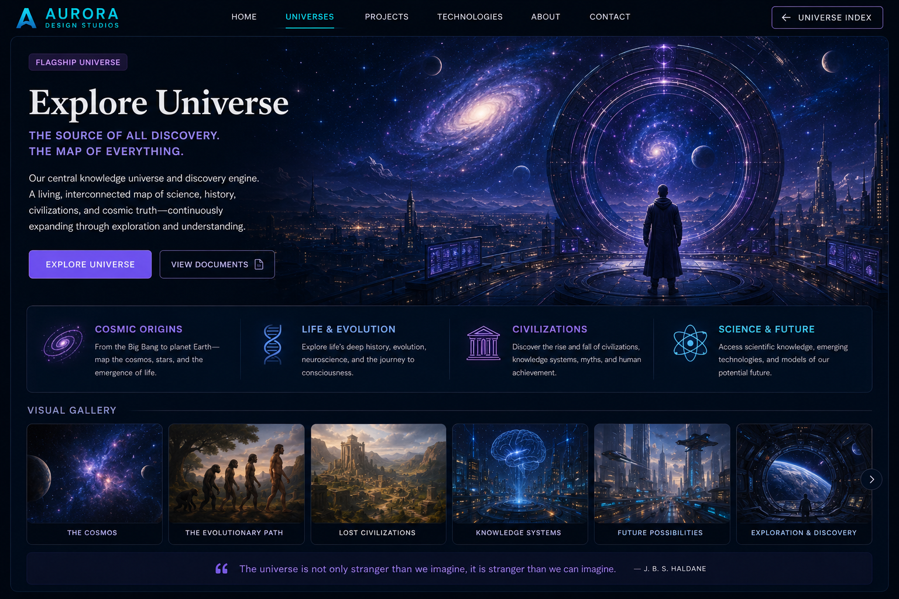
Primary page concept — reference artwork for the DreamStream folder and webpage build.

Alternate / reference concept
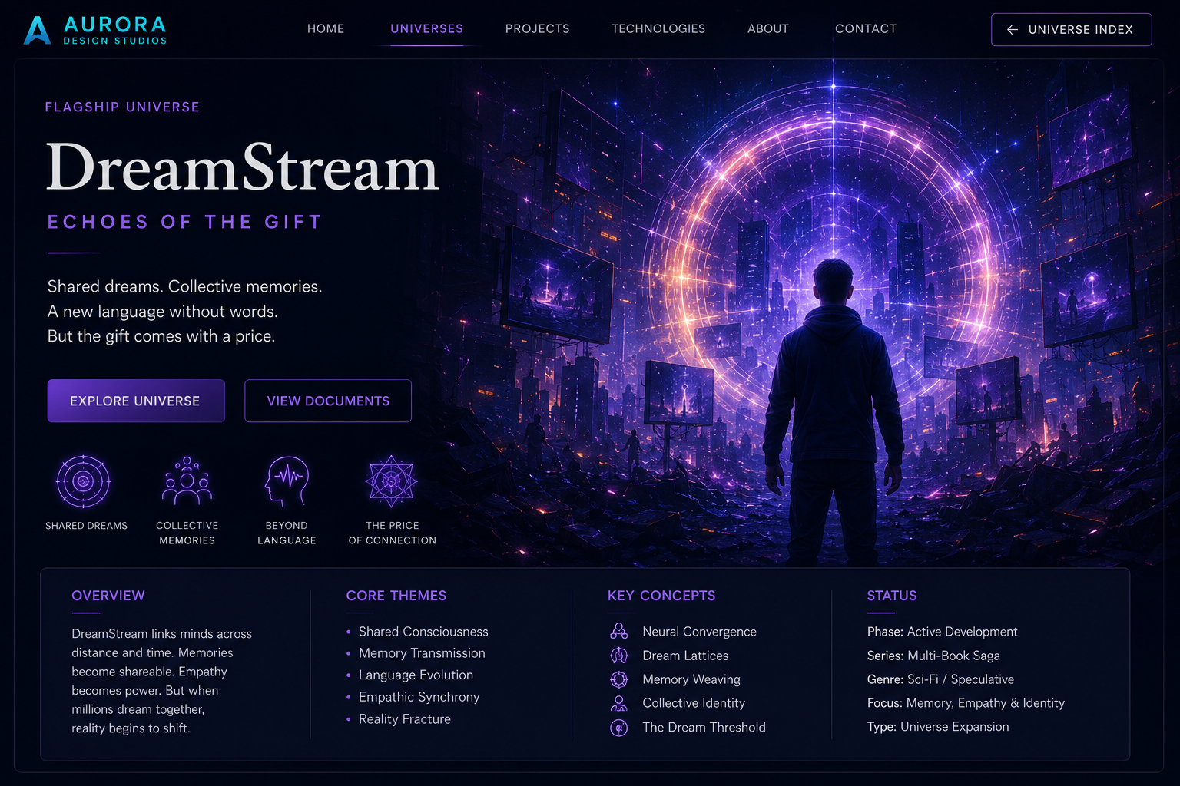
Alternate / reference concept — reference artwork for the DreamStream folder and webpage build.

2.0 Hero Copy
DreamStream
Echoes of the Gift
Shared dreams. Collective memories.
A new language without words.
But the gift comes with a price.

3.0 Universe Overview
DreamStream begins with a simple question: what if a dream could be preserved?
What starts as dream recording evolves into memory sharing, emotional recovery, accelerated learning, and humanity’s first exploration of shared consciousness.
Researchers develop technologies capable of recording fragments of dreams before they fade. The breakthrough leads to something far greater than memory preservation. Dreams become shareable. Memories become transferable. Consciousness itself becomes a frontier of exploration.
As millions connect through DreamStream, humanity discovers that understanding another person completely may be both its greatest achievement and its greatest danger.

4.0 Core Themes and Key Concepts
Core Themes | Key Concepts
Shared consciousness | Neural convergence
Memory transmission | Dream lattices
Language evolution | Memory weaving
Empathic synchrony | Collective identity
Reality fracture | The dream threshold
Grief and healing | Dream preservation

5.0 Book Scope
DreamStream should stay as a one- or two-book project unless the story later demands more. Current recommendation: two books maximum.
Book | Working Title | Function
Book 1 | DreamStream: The First Dream | The invention story: founders, grief, dream journals, first prototype, first preserved dream.
Book 2 | DreamStream: Echoes of the Gift | The consequence story: public release, shared dream networks, education, therapy, empathy, identity risk.

6.0 Webpage Structure
- Hero section
- Icon row: Shared Dreams, Collective Memories, Beyond Language, The Price of Connection
- Overview / Core Themes / Key Concepts / Status panel
- Two-book saga section
- Timeline of discovery
- Visual gallery
- Project documents note
- Closing quote

7.0 Folder Structure
original-universes/
└── dreamstream/
├── index.html
├── img/
│ ├── dreamstream-hero.webp
│ ├── dreamstream-card.webp
│ ├── shared-dreams.webp
│ ├── dream-lattice.webp
│ └── dream-threshold.webp
├── books/
│ ├── book-1-the-first-dream/
│ └── book-2-echoes-of-the-gift/
└── docs/
└── DreamStream_Webpage_Design_Brief.docx

8.0 Image Rules
- Use WebP for webpage graphics.
- Keep each webpage graphic under 1 MB.
- Book cover graphics should live inside the individual book folders.
- General page graphics should live in dreamstream/img/.
- When the DreamStream device rendering is ready, add it as dreamstream/img/dreamstream-device.webp and create a “DreamStream System” section.

9.0 Implementation Note
Do not change the Original Universes landing page during this pass. It already displays the DreamStream card. The immediate task is to create the missing DreamStream destination folder and homepage, then move on to the remaining three missing flagship destination pages.

